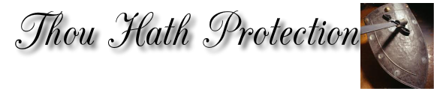
Printed Catalog
Armor
Best Deal!
|
\|/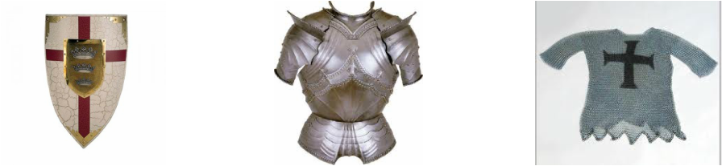
1) 2) 3) 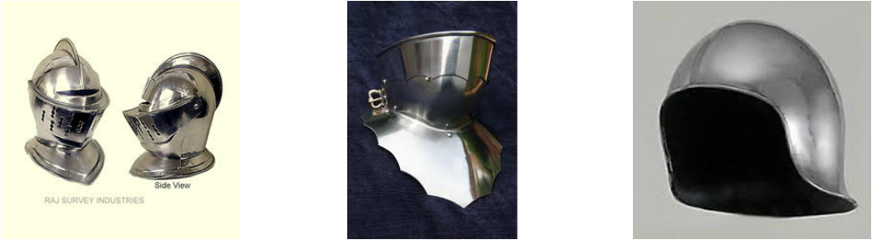
4) 5) 6)
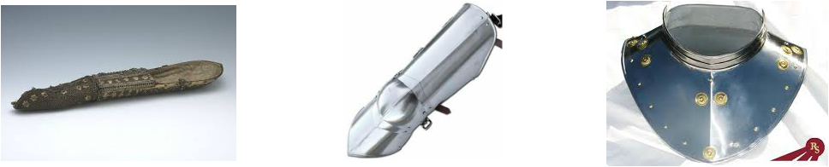 7) 8) 9)
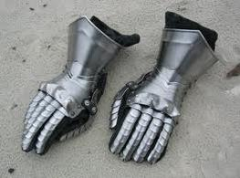
10)

Weapons
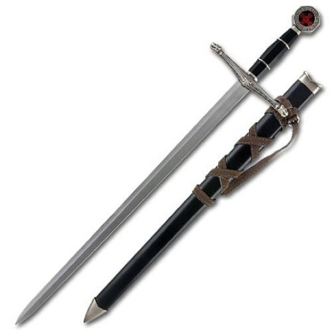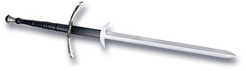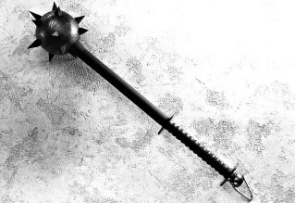
11) 12) 13)
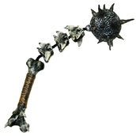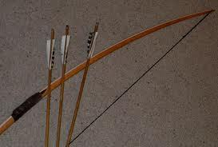
14) 15)

- This shield is created by the best blacksmith in the entire continent using the strongest of steel. This shield can withstand almost any attack, possibly saving your life multiple times on the battle field. Also this intricate shield has King Arthur’s personal coat of arms. This amazing shield is currently offered at 3 golden coins.
- This light weighted chest plate is perfect for any knight who wants for protection. Made with metal mixed diamonds, this majestic piece of can withstand attacks up to a cannonball. Although this armor uses 5 times more steel than an ordinary chest plate, it weighs 30lbs. Tightly welded, not the thinnest blade can pass through the slits. No arrow or blade will be able to penetrate it. This wonderful equipment can be bought for only 7 golden coins.
- This carefully crafted chain mail is made of twice as many links as an ordinary mail and is twice as thick; these aspects increase protection. You may assume that this mail is extremely heavy but because the links are hollow it weighs as heavy as a typical mail. Each link on masterpiece is slowly handcrafted expert royal blacksmiths. Even though arrows might penetrate this mail, it will protect you from all shock warfare. This beautiful mail can be yours for only 6 golden coins.
- This slowly polished helmet will be able to divert and stop any blow to the head. The helmet also features a hinged visor that can be lifted for wider vision. The slit on the visor is carefully crafted in shape of a horizontal arrow hoop, allowing the wearer to see through but this stops any weapon that attempts to go through. The pieces of the helmet are perfectly fitted together so there are no openings that allow a weapon through. This sturdy helmet is on sale for only 4 golden coins.
- This beautiful hinged visor can be attached to any helmet you desire. Made of incredibly strong steel this light visor can be easily carried with you and be attached at any moment. Polished for a perfect shine, this helmet is promised to withstand all scratches. This almost unbreakable visor is for 1 golden coin.
- This sallet is forged especially for archers for protection while still maintaining
lightness for shooting arrows. Although this helmet may not offer much
protection to the front of the face but it will be able to deter any arrow to the
head. Made of an alloy of bronze, steel, and silver this sallet is one of the strongest headpieces for archer in the entire continent; we understand how important your archers are to you so we also added a second layer of chainmail. This important helmet can be brought for 2 golden coins.
- This almost unbreakable brassat is not only forged with two layers of iron it is also wrapped with a layer of chainmail. This piece of armor is created to protect your arm from any attack so you can block with it if lose your shield or sword. We use twice as many plates of metal as an ordinary brassat so you can bend more easily. This doesn't to the weight because our plates are actually three times as small a typical arm guard. There is leather padding inside the brassat for it wouldn't chafe your arm. At each end there are leather straps that tie your brassat to your chest plate and gauntlets. This strong brassat is only sold for 2 golden coins.
- These amazing cuisses are crafted to protect your knee and shin. With 5 bendable plates you are able to flex into any position. Although it is only half greaves multiple plates attached to the back straps enhances its ability to deflect blows. Quickly dipped in water after welding adds to the metal's strength. Built for riding horses these cuisses have extremely sharp edges that can cut your enemy while you are riding on your horse. These amazing cuisses are currently offered at 2 golden coins.
- This stupendous neck guard will be able to save your life multiple times. With an extendable neck piece you are able adjust how high on your neck you want to be protected to. Equipped with dozens of golden button and other precious metals, this neck guard will be able to wow your opponents in mid-battle. Coated with our special see- through metal no special decoration will be damaged. With two layers of iron this guard will be almost impermeable; no
attack will be able to land through. This lifesaving neck guard will only cost you 2 golden coins.
- These powerful gauntlets are able to knock out your opponent in a few strokes. With a leather layer your sword handling will be optimized; unlike other gauntlets, this gauntlet is created with multiple curves so your opponent will have a hard time planting a firm hard blow on you. Multiple straps will allow you to securely tie the gauntlet to you brassat without it falling off. This irresistible gauntlet will only cost you 2 golden coins.
- This magnificent sword is quite effective in taking down enemies more swiftly.. This sword may not have a sharp blade, but its lightweight makes up for it. This amazing sword only weighs three to five pounds. This allows for swiftness in the battlefield and will prove extremely useful when you are in a tight situation and every second counts. This sword is only for the low price of five golden coins.
- This sword is extremely in making huge attacks against your enemies. The length of the sword is fifty to seventy two inches. It has an extremely sharp blade and can penetrate easily through armor. It is especially useful for cutting an enemy’s limbs and head off. The only minor detriment is its heavyweight, which ranges from six to ten pounds. For the price of 7 golden coins.
- A mace is most effective in demolishing your enemy’s armor. This weapon is usually used on horseback and is used for close combat. It is quite similar to the fail but the main difference is that the mace is more effective in close combat. This weapon is extremely easy to make and that is why is only costs 3 gold pieces.
- This flail is extremely useful offensive weapon used for close combat. Each hit will give your enemy a heavy blow. Not even the strongest shields could defend your opponents from this weapon. This weapon is good in any position, whether you are on horseback or on foot. This absolutely amazing weapon is only 8 gold pieces.
- This amazing bow is extremely light with a length of six feet. If you are a good archer with perfect aim, this is the weapon for you. It had a range of two hundred yards, and when handled by a good archer it is extremely accurate, so accurate that it will
be able to nail a falling leaf to a tree.

Item Name | Price of Item | Number of Item | Price
1)
2)
3)
4)
5)
6)
7)
8)
9)
10)
11)
12)
13)
14)
15)
16)
 |  | Subtotal:
 |  | Tax/Discount:
 |  | Total Price:

Last Name: First Name:
Shipping Address::
Po Box:
Street:
City: State: Zip Code:

[] Check [] Credit Card::
[] Visa [] MasterCard [] American Express
Name (exactly as listed on card):
Card Number: Security Code:
Date of Expiration:

